Connor Johnson

Problem Set 4

6. The acf didn’t converge to zero and had a wave with a period of about 12 which suggests seasonal data. I selected a seasonal ARMA(1,1) model after analyzing the acfs which gives the following predicted data.

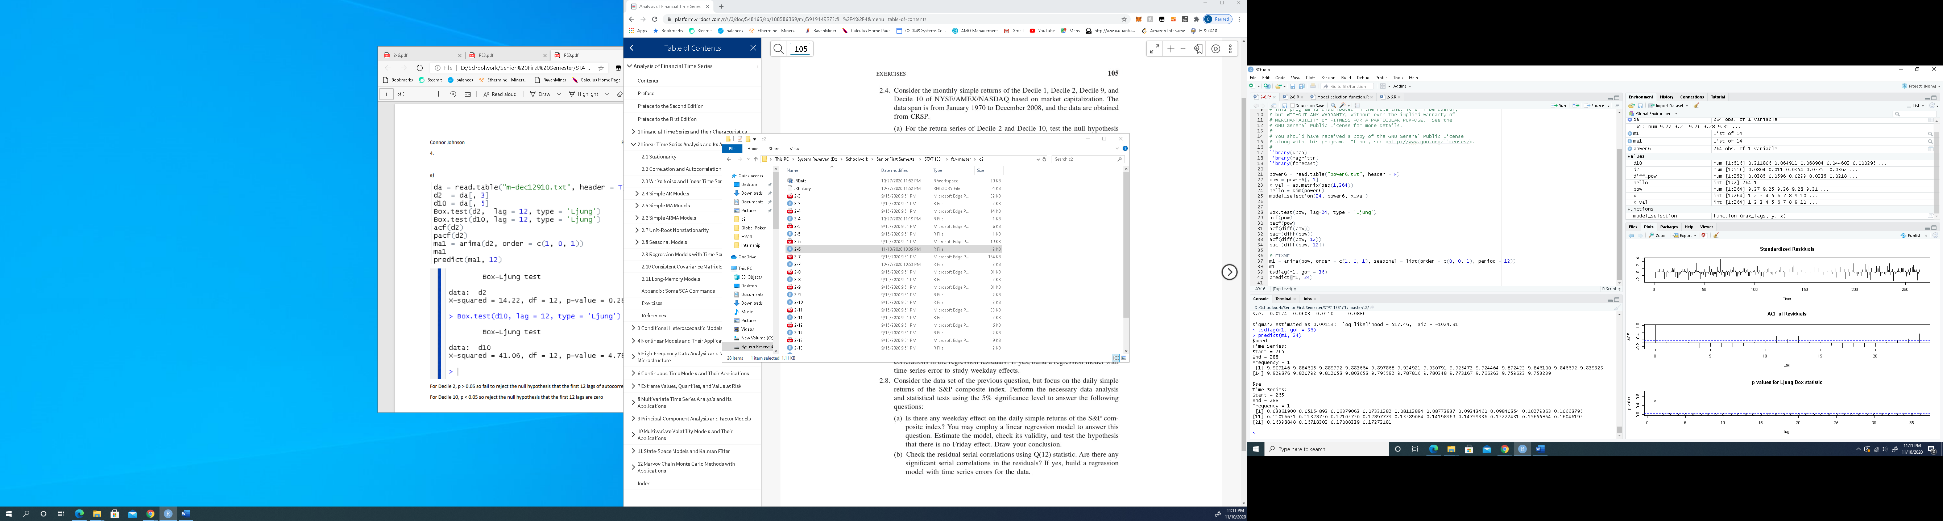

8.

Residuals:

Min 1Q Median 3Q Max

-20.4627 -0.5214 0.0142 0.5379 11.5842

Coefficients:

Estimate Std. Error t value Pr(>|t|)

M -0.004214 0.029944 -0.141 0.8881

Tu 0.074036 0.028855 2.566 0.0103

W 0.063973 0.028836 2.219 0.0265

Th 0.006432 0.029128 0.221 0.8252

Fr 0.032896 0.029228 1.125 0.2604

The null hypothesis is that the Friday coefficient is zero. The Friday coefficient has a t value of 1.125 and p value of 0.2604. Thus, there is not enough evidence to show the Friday coefficient is significantly different from zero. So , it can be concluded there isn’t a Friday effect.

